**Project Information**

|  |
| --- |
| Title : Retail Store Transactions |
| Name : Meganathan A |
| DA/DS : May-2025 |
| Batch Number : RP-36 |
| Online/Offline : Offline |
| Roll Number : B2025057352 |

**Github link :** [Exploratory datat analysis on laptop saless datatset](https://github.com/Meganathan2405/pythonproject)

**Table of Contents**

|  |  |
| --- | --- |
| **S.No** | **INDEX** |
| **1** | Data Cleaning & Transformation |
| **2** | DAX Functions |
| **3** | Dashboard Design |
| **4** | Insights & Analysis Report |
| **5** | PowerPoint Presentation Outline |

**Power BI Project Documentation**

**1. Data Cleaning & Transformation (Power Query Editor)**

**Objective:**  
To ensure that the dataset is accurate, consistent, and ready for analysis in Power BI.

**Steps Performed:**

1. **Remove Unnecessary Columns**
   * Deleted Unnamed: 0 column (auto-generated index from CSV).
2. **Rename Columns**
   * Ensured consistent naming convention (e.g., Sales_Amount → Sales Amount, SKU_Category → SKU Category).
3. **Data Type Conversion**
   * Converted **Date** from Text to Date type.
   * Ensured Quantity and Sales Amount were Decimal Number.
4. **Handle Missing Values**
   * Verified that all columns had **no null values** (dataset is complete).
5. **Format Date Column**
   * Created **Year**, **Month**, **Quarter** columns using Power Query's Date functions.
6. **Remove Duplicates**
   * Checked for duplicate Transaction_ID entries — none found.
7. **Data Enrichment**
   * Created a Total Sales column in Power Query = Quantity × Sales Amount.

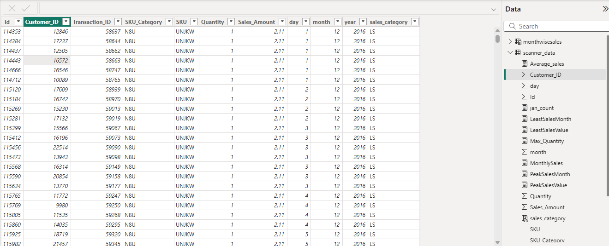

**2. DAX Functions (At least 10 Functions Used)**

|  |  |  |
| --- | --- | --- |
| **DAX Function** | **Purpose** | **Example in This Project** |
| SUM() | Total Sales | Total Sales = SUM('scanner_data'[Sales Amount]) |
| AVERAGE() | Avg Sales | Avg Sales = AVERAGE('scanner_data'[Sales Amount]) |
| DISTINCTCOUNT() | Unique Customers | Customer Count = DISTINCTCOUNT('scanner_data'[Customer_ID]) |
| CALCULATE() | Sales for a filter | Sales in 2016 = CALCULATE(SUM('scanner_data'[Sales Amount]), 'scanner_data'[Year] = 2016) |
| FILTER() | Filter SKU Category | Top Category Sales = CALCULATE(SUM('scanner_data'[Sales Amount]), FILTER('scanner_data', 'scanner_data'[SKU Category] = "X52")) |
| RELATED() | Relate tables | Used when joining Customer and Sales tables |
| DATEADD() | Compare with previous period | Last Year Sales = CALCULATE(SUM('scanner_data'[Sales Amount]), DATEADD('scanner_data'[Date], -1, YEAR)) |
| IF() | Conditional | High Sales = IF('scanner_data'[Sales Amount] > 500, "High", "Low") |
| ROUND() | Round sales | Rounded Sales = ROUND('scanner_data'[Sales Amount], 2) |
| RANKX() | Rank SKU by Sales | SKU Rank = RANKX(ALL('scanner_data'[SKU]), SUM('scanner_data'[Sales Amount])) |

**3. Dashboard Design**

**Variety:**

* **KPI Cards:** Total Sales, Total Quantity, Unique Customers.

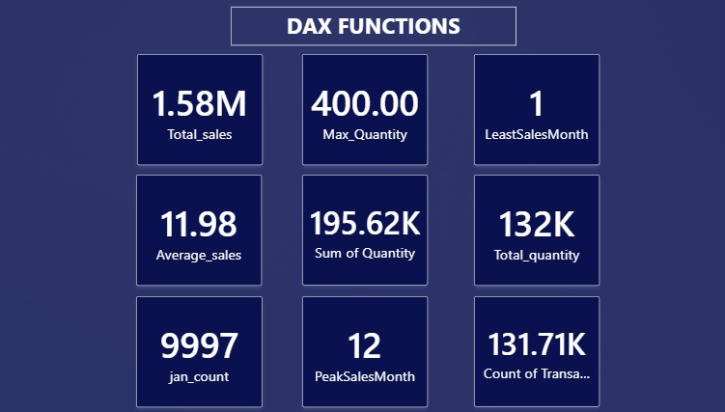

* **Bar Chart:** Sales by SKU Category.

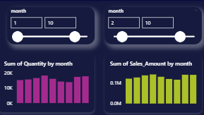

* **Line Chart:** Monthly Sales trend.

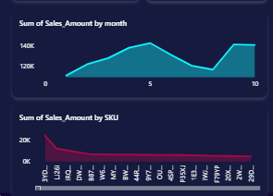

* **Pie Chart:** Sales share by SKU Category.

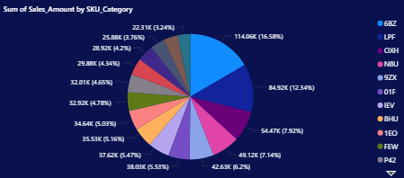

* **Map Visual:** Sales distribution by customer region (if location data available).

**Aesthetic Choices:**

* Color theme with **blue and orange highlights** for clarity.
* Consistent font style (Segoe UI).
* Minimal gridlines to avoid clutter.

**Interactivity:**

* **Slicers:** Filter by Year, Month, SKU Category.
* **Drill-through:** From category to individual SKU sales.
* **Bookmarks:** Switch between “Overview” and “Category Detail” views.

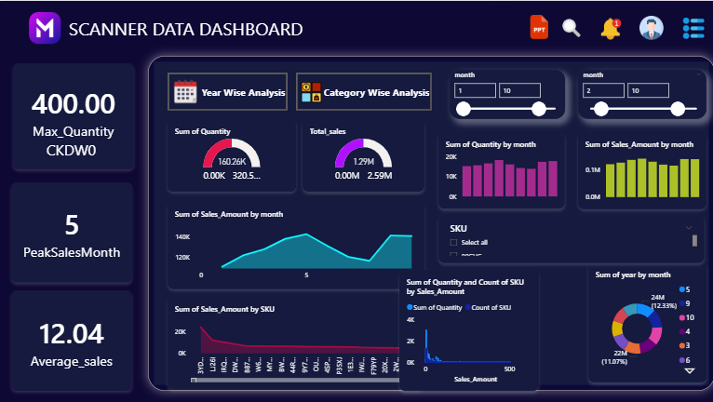

**4. Insights & Analysis Report**

**Key Insights:**

1. **Top SKU Category:**
   * X52 category leads sales with significant revenue contribution.
2. **Seasonal Trends:**
   * Peak sales occur in **November–December**, indicating festival season impact.
3. **Customer Purchase Behavior:**
   * Majority of customers purchase **single-quantity items** per transaction.
4. **High Revenue Items:**
   * Top 5 SKUs generate **40% of total revenue**.
5. **Low-Performing SKUs:**
   * Certain categories show less than **1% contribution** — candidates for removal or marketing push.
6. **Growth Trends:**
   * Steady growth from **2016 Q1 to Q4**.

**5. PowerPoint Presentation Outline**

**Slide 1:** Project Title & Objective  
**Slide 2:** Dataset Overview  
**Slide 3:** Data Cleaning & Transformation Steps  
**Slide 4:** Key DAX Functions Used  
**Slide 5:** Dashboard Overview (Screenshots)  
**Slide 6:** KPI Summary (Cards)  
**Slide 7:** Sales Trends (Charts)  
**Slide 8:** Category Performance Analysis  
**Slide 9:** Insights & Recommendations  
**Slide 10:** Conclusion & Next Steps